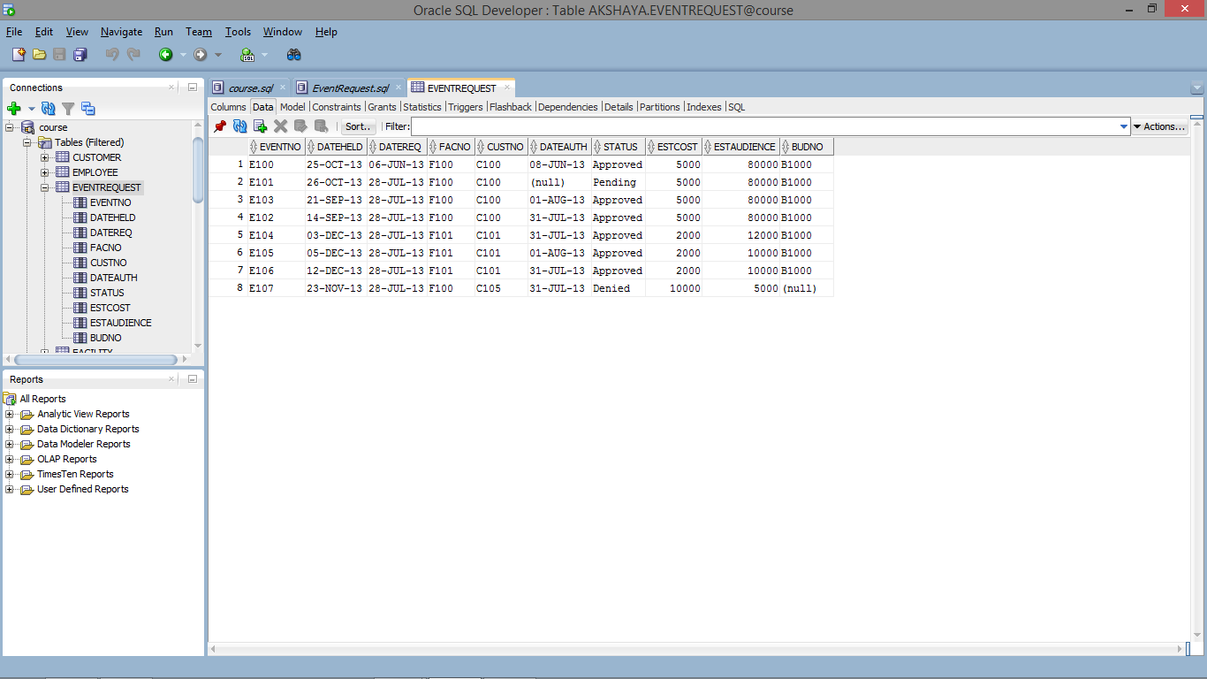

--Constraint check added after populating table--

CREATE TABLE EventRequest

(

eventno CHAR(8) PRIMARY KEY NOT NULL,

dateheld DATE NOT NULL,

datereq DATE NOT NULL,

facno VARCHAR2(8) NOT NULL,

custno VARCHAR2(8) NOT NULL,

dateauth DATE,

status VARCHAR2(8) NOT NULL,

estcost DECIMAL(10, 2) NOT NULL,

estaudience INT NOT NULL,

budno CHAR(8),

CONSTRAINT facnoFK FOREIGN KEY (facno) REFERENCES FACILITY (FacNo),

CONSTRAINT CustNoFK FOREIGN KEY (custno) REFERENCES CUSTOMER (CustNo),

CONSTRAINT ChkStatus CHECK (status IN ('Approved', 'Denied', 'Pending'))

);

INSERT INTO EventRequest (

eventno,

dateheld,

datereq,

custno,

facno,

dateauth,

status,

estcost,

estaudience,

budno

) VALUES (

'E100',

TO_DATE('25-OCT13','DD-MON-RR'),

TO_DATE('06-JUN-13','DD-MON-RR'),

'C100',

'F100',

TO_DATE('08-JUN-13','DD-MON-RR'),

'Approved',

5000,

80000,

'B1000'

);

INSERT INTO EventRequest (

eventno,

dateheld,

datereq,

custno,

facno,

dateauth,

status,

estcost,

estaudience,

budno

) VALUES (

'E101',

TO_DATE('26-OCT13','DD-MON-RR'),

TO_DATE('28-JUL-13','DD-MON-RR'),

'C100',

'F100',

NULL,

'Pending',

5000,

80000,

'B1000'

);

INSERT INTO EventRequest (

eventno,

dateheld,

datereq,

custno,

facno,

dateauth,

status,

estcost,

estaudience,

budno

) VALUES (

'E103',

TO_DATE('21-SEP13','DD-MON-RR'),

TO_DATE('28-JUL-13','DD-MON-RR'),

'C100',

'F100',

TO_DATE('01-AUG-13','DD-MON-RR'),

'Approved',

5000,

80000,

'B1000'

);

INSERT INTO EventRequest (

eventno,

dateheld,

datereq,

custno,

facno,

dateauth,

status,

estcost,

estaudience,

budno

) VALUES (

'E102',

TO_DATE('14-SEP13','DD-MON-RR'),

TO_DATE('28-JUL-13','DD-MON-RR'),

'C100',

'F100',

TO_DATE('31-JUL-13','DD-MON-RR'),

'Approved',

5000,

80000,

'B1000'

);

INSERT INTO EventRequest (

eventno,

dateheld,

datereq,

custno,

facno,

dateauth,

status,

estcost,

estaudience,

budno

) VALUES (

'E104',

TO_DATE('03-DEC13','DD-MON-RR'),

TO_DATE('28-JUL-13','DD-MON-RR'),

'C101',

'F101',

TO_DATE('31-JUL-13','DD-MON-RR'),

'Approved',

2000,

12000,

'B1000'

);

INSERT INTO EventRequest (

eventno,

dateheld,

datereq,

custno,

facno,

dateauth,

status,

estcost,

estaudience,

budno

) VALUES (

'E105',

TO_DATE('05-DEC13','DD-MON-RR'),

TO_DATE('28-JUL-13','DD-MON-RR'),

'C101',

'F101',

TO_DATE('01-AUG-13','DD-MON-RR'),

'Approved',

2000,

10000,

'B1000'

);

INSERT INTO EventRequest (

eventno,

dateheld,

datereq,

custno,

facno,

dateauth,

status,

estcost,

estaudience,

budno

) VALUES (

'E106',

TO_DATE('12-DEC13','DD-MON-RR'),

TO_DATE('28-JUL-13','DD-MON-RR'),

'C101',

'F101',

TO_DATE('31-JUL-13','DD-MON-RR'),

'Approved',

2000,

10000,

'B1000'

);

INSERT INTO EventRequest (

eventno,

dateheld,

datereq,

custno,

facno,

dateauth,

status,

estcost,

estaudience,

budno

) VALUES (

'E107',

TO_DATE('23-NOV13','DD-MON-RR'),

TO_DATE('28-JUL-13','DD-MON-RR'),

'C105',

'F100',

TO_DATE('31-JUL-13','DD-MON-RR'),

'Denied',

10000,

5000,

NULL

);

ALTER TABLE EventRequest

ADD CONSTRAINT CHECK (estaudience > 0);